**Selection of Stocks using Relative Strength Index (RSI) in Indian Stock Market for Swing Trades**

|  |  |  |
| --- | --- | --- |
| **V. Swathi** | **T. Varun** | **V. Jayanth** |
| ***Associate Professor, Department of***  ***Computer Science and Engineering,*** | ***Department of***  ***Computer Science and Engineering,*** | ***Department of***  ***Computer Science and Engineering,*** |
| ***Guru Nanak Institutions Technical Campus.*** | ***Guru Nanak Institutions Technical Campus.*** | ***Guru Nanak Institutions Technical Campus.*** |

**Abstract:**

The accuracy of forecasting is the most important factor in selecting any forecasting methods. Research efforts in improving the accuracy of forecasting models are increasing since a long time. The appropriate stock selections those are suitable for investment is a difficult task and is very important for a trader to earn profits. The key factor for each investor is to earn maximum profits on their investments. Numerous techniques used to select the stocks in which fundamental and technical analysis are one among them. In our paper, we have given a keen insight about the selection of stocks using Relative Strength Index (RSI) for swing traders.

**Key Words:**

*Relative Strength Index, RSI, Stock Selection, NSE, BSE.*

**Introduction:**

A stock market is a gathering of buyers and sellers of stocks in a single platform. Before BOLT was introduced in 1995, people used to trade standing in the trading ring. Nowadays, all trading happens in computer terminals at the broker’s office or on the internet. Share market and the stock market is one and the same thing.Most of the trading in the Indian stock market takes place on its two stock exchanges: the Bombay Stock Exchange (BSE) and the National Stock Exchange (NSE). The BSE has been in existence since 1875. The NSE, on the other hand, was founded in 1992 and started trading in 1994. However, both exchanges follow the same trading mechanism, trading hours, settlement process, etc.

Almost all the significant firms of India are listed on both the exchanges. NSE enjoys a dominant share in spot trading, with about 70% of the market share, as of 2009, and almost a complete monopoly in derivatives trading, with about a 98% share in this market, also as of 2009. Both exchanges compete for order flow that leads to reduced costs, market efficiency, and innovation. The presence of arbitrageurs keeps the prices on the two stock exchanges within a very tight range.

Swing trading is a kind of trading where the traders take advantage of short term moments which probably long from few days to several weeks.Most of the traders in swing trade take advantage using the technical indicators provided by their brokers.The goal of swing trading is to capture a chunk of a potential price move. While some traders seek out volatile stocks with lots of movement, others may prefer more sedate stocks. It basically comprises of two types of long and short. Long is where we buy a stock at a certain point and sell it when our target is reached. Short is a type where we first sell the stock and then buy it after the target getting hit.Short option is provided by all the major brokerages in india.

RSI(Relative Strength Index) is an indicator which was originally developed by J. Welles Wilder Jr. and introduced in his seminal 1978 book, New Concepts in Technical Trading Systems.It is a momentum indicator which takes count on the price of the stock and indicates overbought and oversold levels. It is basically a scale of 100 where the overbought levels are above 80 and oversold levels are below 20. We can expect a reversal in the stock after it reaching the overbought or oversold levels.

This paper consists of problem statement, proposed methodology,conclusion and future work. Where we explain in detail about the selection of stocks using RSI.

**Literature Review:**

In the paper published by Adrian Et Al. [1], in comparison with the classic form of the indicator and for the period taken into account, the RSI version proposed by us generated a higher gain when using a different and even opposite interpretation from the classic one and much greater losses in the reverse situation. Therefore, the study concludes that by analyzing the results of the research, the extreme values of the RSI and RSIM do not indicate the return of a trend but the continuation of its direction, at least for the short term. So, the classic interpretation is useless while the reversed interpretation gives positive results for both forms of the indicator.

In the paper published by Hari Et Al. [2], the main output is that the system helps to indicate the time to buy, sell, overbuy, oversold and neutral. Thus, it can help the investor to reflect and prove the decision making. Furthermore the system can help to analyze the historical price data at the selected time interval. The time interval can also affect the result of the prediction, especially the moving average result. Based on the user experience survey, the ease of use in the system is acceptable. Lastly, the system cannot determine the loss or profit, thus this system can only indicate the right time to buy or sell, but all the decision is up to the trader.

In the paper published by Pooja Et Al. [3], the RSI reversal concept applies to all time frame and gives a clear understanding of market trends and also forecasting of market directions.This concept of relative strength is useful not only in highlighting promising investments, but also in enabling you to judge your own performance. While a variety of relative strength measures are available to investors, all attempt to capture stocks showing stronger price movement than that shown by the overall market. Like all investment techniques, proper use requires a careful study and understanding of the factors driving the stock price movement.

In the paper published by Bhargavi Et Al. [4], we can clearly find that RSI is one of the most effective technical analysis tools available, it can be effectively used to create a portfolio. Just as it performs well in other stock markets around the world, it also works well in Indian stock market. It has also been found out that P/E ratio better reflects the performance of an organization when compared to EPS. Although RSI in itself is a very powerful analytical tool, using fundamental analysis and other technical analytical tools along with it gives better results.

**Problem Statement:**

The research problem undertaken in this study is to provide inputs trading strategies. There are about 5000 stocks or scripts available in BSE and more than 1600 scripts are in NSE which makes a trader to become confused to select the right stock in the right period or movement. The selection of the stocks from those huge number of the stocks is not an easy task, it requires a strategy and tools to refine the stocks. Thus, the selection of the right script or stock at the right movement will help the traders to be successful in their trades. As in many cases, investors suffer due to wrong selection of securities in a portfolio. Selection of inappropriate securities may lead to losses being suffered by the investor. And it very difficult to find the appropriate stock or script accurately. In order to overcome this, many tools are available of which RSI is a powerful analytical tool which will help the investor choose the right combination of securities for their portfolio construction. Even there are many methods available in the market, RSI have its own specifications that helps the RSI to be main tool for the technical traders.

The scope of the study is confined to select very few companies listed in NSE. The main objective of this study is to test the validity of RSI results in trading strategies in short term and in the long term market trends and trades.

**Proposed Methodology:**

Relative Strength Index is a powerful tool which helps investors to make investment decisions. To add credence, testing and validation of RSI will be of help, particularly for portfolio construction. The use of RSI helps in minimizing the risk and maximizing the return in respect of the portfolio.

The proposed methodology is basically of following mentioned six phases. They are:

1. Taking the Input stocks and select the stocks as per the mentioned strategy.
2. Get the history data of the stocks.
3. Calculate the Average gain and Average Loss of the stock.
4. Calculate the RSI for the stock.
5. Select the best stocks as per the previous day RSI level (Over.

***Input Stocks:***

Data cleansing or cleaning is the process of identifying and rectifying the corrupt or inaccurate data from a database. In this case, get the previous day stocks data into an excel sheet. Sort out the stocks as per their last traded price (LTP) or value in ascending or descending order. Delete the stocks with more than Rs. 10,000 as LTP and also the stocks with less than Rs. 50 as LTP. Save the excel sheet and this sheet will be used for the further analysis.

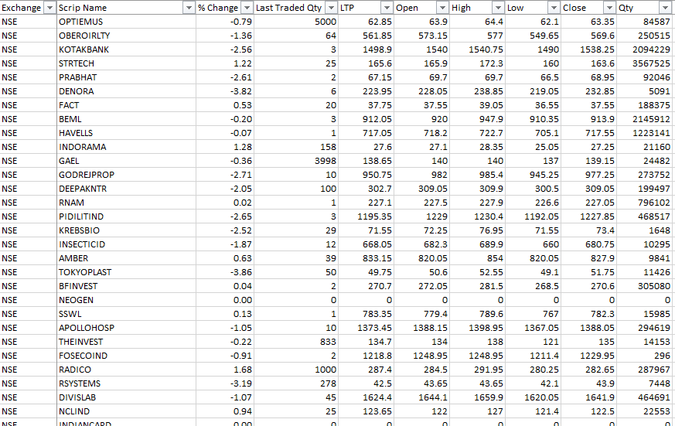

*Table - 1: List of all the stocks and the required parameters*

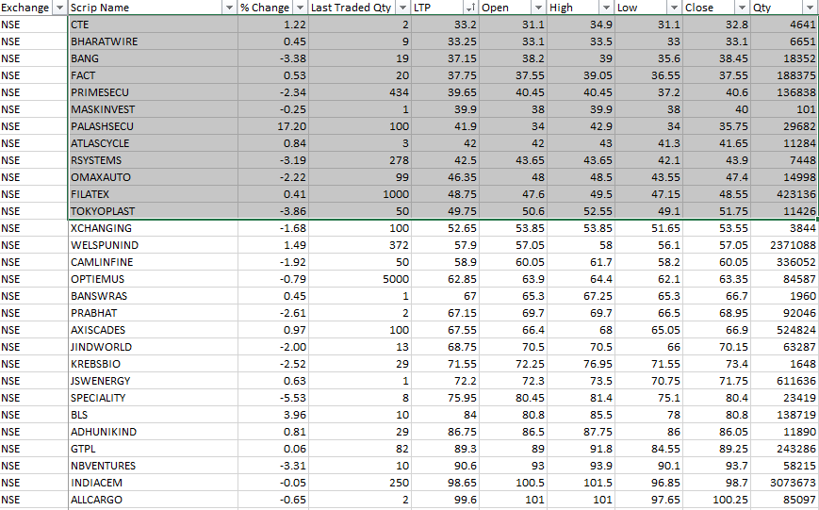

*Table – 2: List of the stocks to be removed (LTP < 50)*

The deletion of the stocks with less than Rs. 50 is just because these stocks will have less volatility even in a trendy market. The market is said to be trendy if the market chooses a trend and follow the trend (either raise of the prices or decrease of the prices). A volatile market is a kind of situation in the market where the prices will not follow the trend of the market and either increases or decreases (go up or fall down in value). These stocks will not have any changes in their prices even in a volatile market. The reason behind the deletion of the stocks with more than Rs. 10,000 is that these stocks require a high amount of investment and have will show a massive response or highly volatile which makes an investor to lose their money easily. Due to the above mentioned reasons and for the ease of the investors in our proposed strategy we try to remove these kind of stocks.

***History of the Stocks:***

From the selected stocks which are sorted out using the above phase are taken and the history of each stock is considered. History of the stock refers to the previous data of the stock. Here, we take the previous day’s data from each stock. The example of this phase is as shown as below:

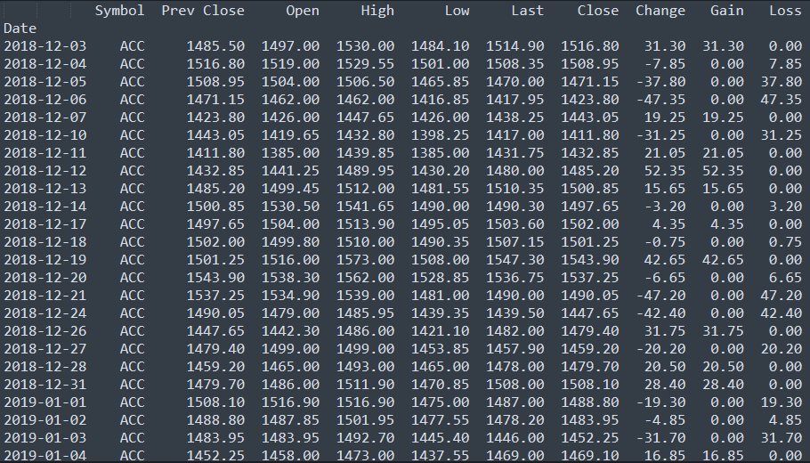

*Table – 3: History of a stock “ACC” with Gain and Loss of the stock*

The above picture tells us that the script or stock name “ACC” is taken from the script list and the history of the data is taken for that script. This phase is used by the next phases and it plays a major role in the selection of the stocks.

***Calculation of Average Gain and Average Loss:***

The history of the stock is used in calculating the average gain and average loss of the stock. The below mentioned formula can be used in calculating the average gain and average loss of the given stock. The average gain or loss used in the calculation is the average percentage gain or losses during a look-back period. The formula uses positive values for the average losses.



Here, n = number of days taken in the history of each stock.

Total Gains = Sum of gain value for the given stock in the past finite number of days.

Total Loss = Sum of loss value for the given stock in the past finite number of days.

***Calculation of the Relative Strength Index (RSI) for the stocks:***

The Relative Strength Index (RSI) is displayed as an oscillator (a line graph that moves between two extremes) and can have a reading from 0 to 100*.*

RSI compares bullish and bearish price momentum plotted against the graph of an asset's price. Calculation of RSI is an easy task for which it requires the previous data of the stock which was taken as the input. From the history data of the stock we can take the required parameters like Gain and Loss to find the average gain and average loss from which we can calculate the RSI for the stock. The formula for calculating RSI is a two-step process and is as shown below:

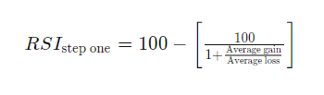

Once there are 14 periods of data available, the second part of the RSI formula can be calculated. The second step of the calculation smooths the results.

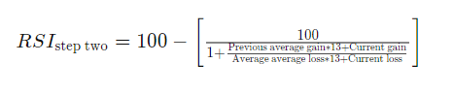

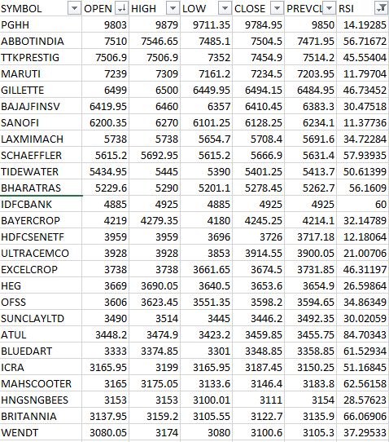

*Table – 4: Calculated RSI for all the selected stocks.*

***Selection of the best stocks using the calculated RSI values:***

From the calculated RSI values for the selected stocks, we select only few best stocks to do the swing trades. Every stock which need to be selected has to follow a rule from the following two rules:

1. RSI value should be below 30 (Oversold)
2. RSI value should be above 70 (Overbought)

If the stock satisfies at least one in between the above mentioned rules, then it is eligible to be selected for the trade. Oversold condition is when the stock has reached its lowest bottom of its price over a period a period of time let’s say 1 week, and it is the time for the stock to raise up to neutralize. Overbought condition of the stock is when the stock has reached its highest high of its price over a period of time let’s say 1 week, and it has to go down to neutralize.

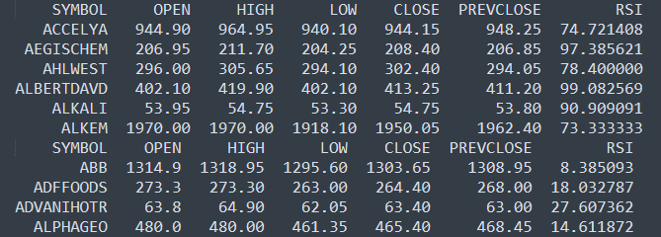

*Table – 5: Sorted list of the stocks with Overbought and Oversold positions of RSI.*

In oversold condition, the RSI value reaches to 30 or even below, where the stock price reaches the oversold position and the stock price raises up. If these kind of stocks are identified at foremost that would be helpful for a trader to some profits out of it. At the position where the RSI is about to raise up will be the best place for a trader to buy that stock to make money out of it. As we know that there will be some limitations for anything which was created on the earth, this method has some limitations. In this position where the RSI is about to go up or increase will help out the trader to buy the stock at the lower level of RSI i.e., at the lowest value of the stock price and sells at the higher price level where the RSI completely reaches the upper or touches the overbought position of the stock. The price of the stock may not raise completely and sometimes it may go down which will completely rely on the overall market trend.

In overbought condition, the RSI value reaches to 70 or even above, where the stock price reaches the overbought position and the stock price decreases. If these kind of stocks are identified before, then it will be very helpful for a trader to get out of the trade of that particular trade or even to short the stocks. In this position where the RSI is about to go down or decrease will help out the trader to short the stock at the higher level of RSI i.e., at the peak value of the stock price and buy at the bottom price level where the RSI completely reaches the bottom or touches the oversold position of the stock. As similar to overbought position of RSI this method has also some limitations where the price of the stock completely depends on the overall market trend.

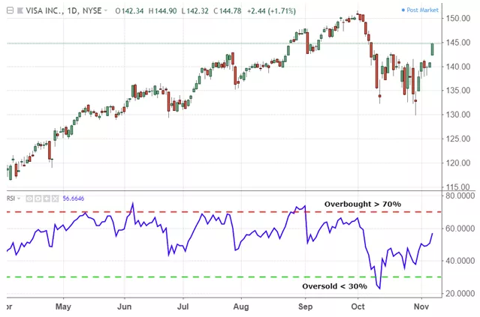

*Figure - 1: Overbought and Oversold positions of RSI which helps to do a Swing trade for a trader.*

The above mentioned chart gives a complete overview of the stock to undergo a swing trade by a trader. This chart covers the whole overbought and oversold positions of the RSI values. The below chart unlike the candle chart is the RSI plot. Using the RSI plot a trader can easily identify the situation of the stock which was taken and may proceed to complete a swing trade where the stock will need some time (days) to change its trend and retreat back. During the trend creation and trend retrieval the trader can complete a successful trade with good amount of profit.

**Conclusion:**

The research paper will give a keen insight of the usage of the RSI in the stock market. Using the above mentioned method a trader can select few best stocks from a large amount of stocks. It also tells about the swing trade, overbought and oversold positions of the stocks. With the help of above mentioned algorithm for the selection of stocks a trader will get more profits with less complexity of the trades. This method was already implemented by some of the successful traders.

**Future Work:**

We are working on enhancement of the above mentioned algorithm using a Machine Learning algorithm that helps to find the trend of the RSI and predict the future RSI value along with its trend, where the machine learning model needs to be trained with the time series data of each and every stock history data to produce the predictions of each stock price for the next few days.

**References:**

[1]. Adrian Ţăran - Moroşan, “The relative strength index revisited”, African Journal of Business Management Vol. 5(14), pp. 5855-5862, 18 July, 2011.

[2]. Yulius Hari and Lily Puspa Dewi, “Forecasting System Approach for Stock Trading with Relative Strength Index and Moving Average Indicator”, Journal of Telecommunication Electronic and Computer Engineering, Malaysia, Vol. 10 No. 2-3.

[3]. Pooja Talreja, “Forecasting Stock Market Trend Using Relative Strength Index”, IJLTEMAS, Volume III, Issue VI, June – 2014.

[4]. Dr. Bhargavi. R, Dr. Srinivas Gumparthi, and Anith. R, “Relative Strength Index for Developing Effective Trading Strategies in Constructing Optimal Portfolio”, International Journal of Applied Engineering Research Volume 12, Number 19 (2017) pp. 8926-8936.

**Weblinks:**

https://stockcharts.com/

https://www.investopedia.com/

https://www.nseindia.com/

https://en.wikipedia.org